SUPA Accepting Applications for
Writing and English Classes: WRT 105, WRT 114, ENG 181 and 192

Dear SUPA Community:

We are pleased to announce that the Syracuse University Department of Writing Studies, Rhetoric and Composition has authorized SUPA to expand our WRT 114: Introduction to Creative Nonfiction and WRT 105: Practices of Academic Writing courses to additional partner schools. We are able to accept up to five new WRT 114 school partners into the program for the 2021 Summer Institute, and we have a limited number of new schools for WRT 105.

Schools interested in running a writing course in a two-course sequence may consider that it is most common to pair WRT 105 with either WRT 114 or with an English and Textual Studies literature course. Our ENG course offerings are ENG 181: Class and Literary Texts and ENG 192: Gender and Literary Texts. Schools that intend to train a teacher for a two-course sequence during the 2021 Summer Institute should contact Sean M. Conrey (contact info below) if they have any questions about which sequence is the best fit for their school.

We will be accepting New Teacher applications for 2021 Summer Institute workshops for WRT 105, WRT 114, ENG 181 and ENG 192 through Friday, May 21, 2021.

Please note: We will only review completed applications that are on file by the deadline (i.e., all required application materials must be submitted by that time). Given the restrictions on the number of schools we can invite into the program next summer for WRT 105 and for WRT 114, we ask that only schools intending to offer the course(s) next school year apply.

Our faculty liaisons for each course will review all completed applications, and SUPA will notify instructors who have been approved to participate in our SUPA Summer Institute training workshops for WRT 105 and WRT 114 by the first week of June. A completed application is not a guarantee of approval for an instructor to attend the Summer Institute. We also note that training sessions for WRT 105 and WRT 114 are being offered during the same week of Summer Institute 2021 (July 19-23), so any instructor or school hoping to offer a year-long, 6-credit WRT 105/WRT 114 course sequence should contact Sean M. Conrey to discuss logistics.

Additionally, instructors who are approved to attend the Summer Institute must successfully complete all workshop requirements in order to gain certification to become a Syracuse University adjunct instructor to teach these courses. This includes completing all reading assigned prior to Summer Institute and arriving prepared to engage in seminar discussions, writing exercises, and course planning activities. SU courses cannot be offered for credit at the high schools without a certified instructor.

In the case of extraordinary interest in these classes, we will keep a waitlist of interested partner schools based on the applications we have on file by the May 21, 2021 deadline. If a selected school partner withdraws from either the WRT 105 or WRT 114 workshop prior to the Summer Institute, we will invite another instructor to participate in the Summer Institute based on the waitlist.

All New Teacher applicants are required to complete the online application (located here) and to submit copies of their undergraduate and graduate transcripts and letters of recommendation. Generally, a master's degree in the subject area and five years of classroom teaching experience are required to become an SU adjunct instructor.

Along with the standard application materials, WRT 105 and WRT 114 have additional requirements for application:

WRT 105:
- A 1-page cover letter detailing one's background or experience in teaching academic writing and pedagogical approach to teaching analysis and argument.
- Optional: a brief, 2-3 page academic writing sample.

WRT 114:
- A 1-page cover letter detailing applicant's background and interest in the teaching, study, and practice of creative writing, other relevant teaching experiences, and publications in any creative writing genre, but especially in creative nonfiction.
- A brief (3-5 pp., double-spaced) creative writing sample (creative nonfiction preferred; please specify the genre of your submission in the header).

For more information regarding WRT 105 and WRT 114 required course texts, course content and policies, etc., please see:

Writing 105 web page
Writing 114 web page

For schools interested in running the Writing and Literature course sequence, please see the following for required course texts, course content and policies, etc. for Syracuse University’s English and Textual Studies classes:

English and Textual Studies 181: Class and Literary Texts
English and Textual Studies 192: Gender and Literary Texts

English and Textual Studies classes also have additional requirements for application:

ENG 181 and 192

- In addition to the standard materials, a one-page cover letter detailing the teacher’s experience with literary theory, as both a student and as a teacher.

Instructors at schools currently offering WRT 105, WRT 114, ENG 181 and 192 may continue to apply to attend the Summer Institute to train as a back-up instructor for these courses.

Please feel free to contact me with any questions.

Sincerely,
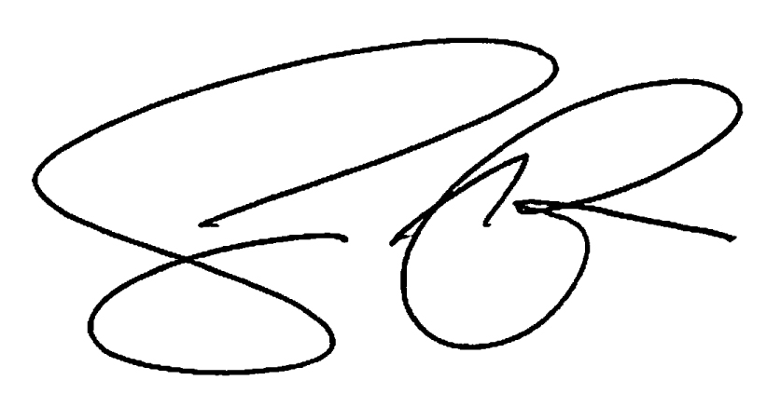
Sean M. Conrey, Ph.D
Assistant Director
Syracuse University Project Advance
smconrey@syr.edu

